1. **Boot computer from USB**
   1. Insert the USB drive in your PC.
   2. Turn on your PC and keep pressing **F12** until bios GUI opens.
   3. Select the USB as boot option.

(add picture)

* 1. Connect to the internet network advised.

(optional: add more instructions)

1. **IIO Oscilloscope**
2. **Transmit and receive a complex sinusoid with Python (Pluto)**
   1. Make the following setup using Pluto and connect it to your PC:

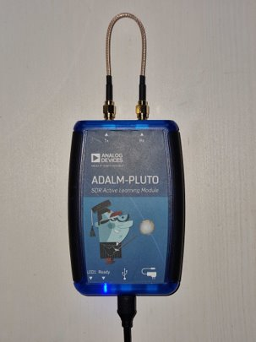

* 1. Open **ftc2023_sdr** folder from your desktop.
  2. Go to **python -> sinewave_loopback** subfolder.
  3. Right click on **python_loopback_sine_pluto.py -> Open With Other Application** and select **Thonny** from the Recommended Applications list.

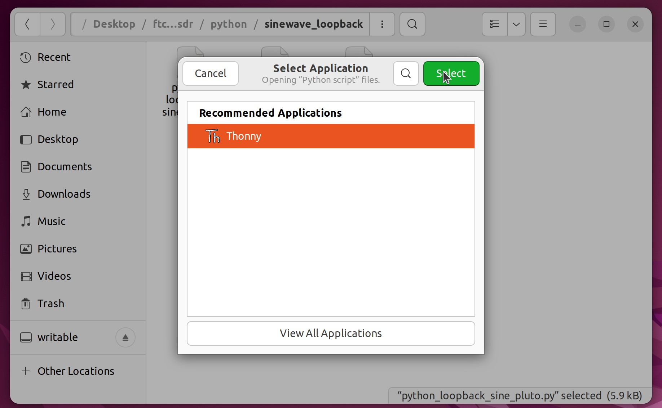

* 1. To run the script, press the green round button from the top left corner in Thonny IDE.

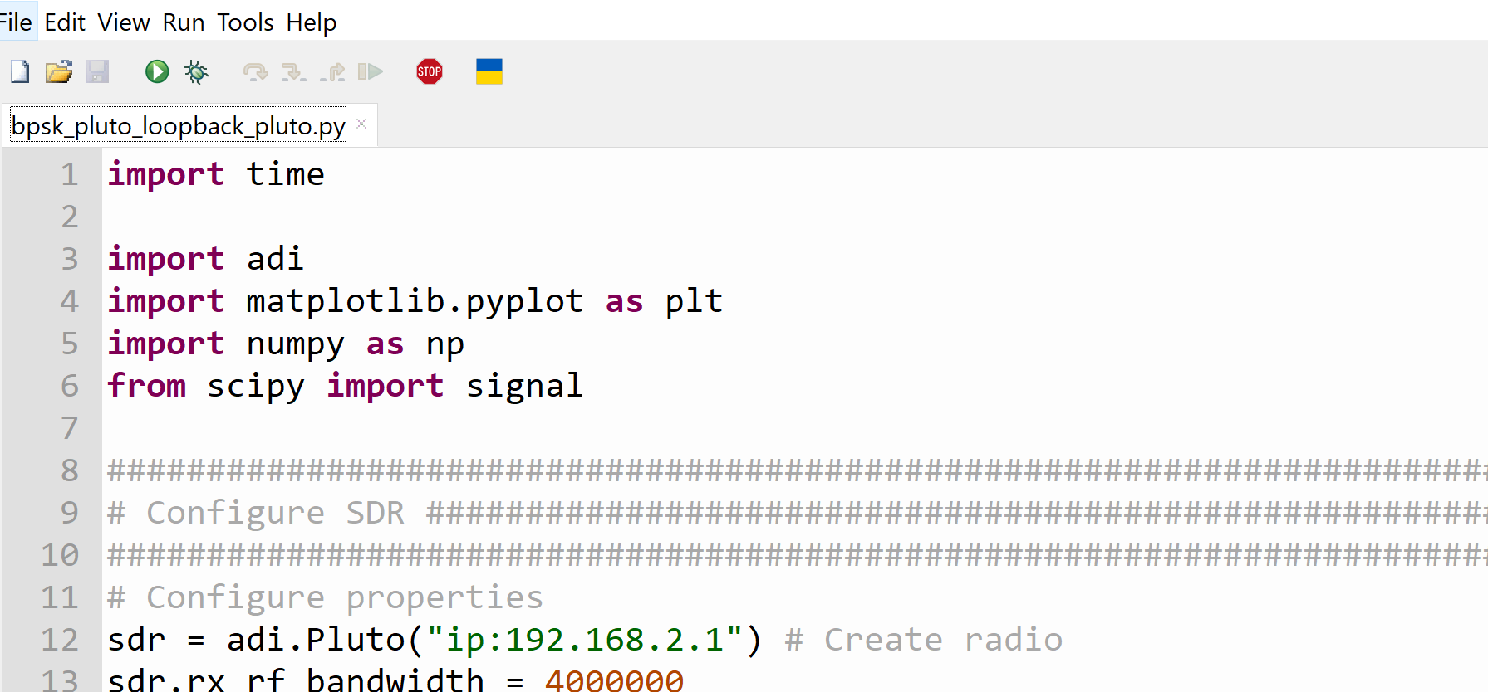

* 1. To zoom on a plot, you can use the zoom option as depicted below and encircle holding left click the area you want to zoom. On this example, if you zoom on Figure 5 on the received signal, you should see a harmonic at 20KHz.

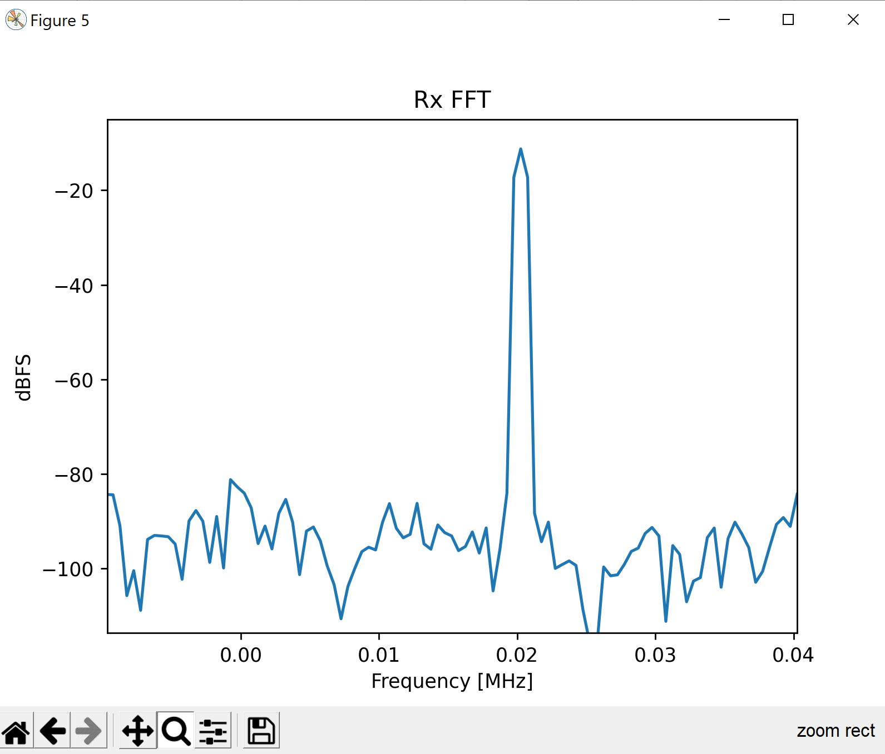

* 1. To stop running the python script (if you want to run it again or run another script), close all the tabs by **right clicking on taskbar icon -> Quit x windows** as depicted below or close them manually one by one.

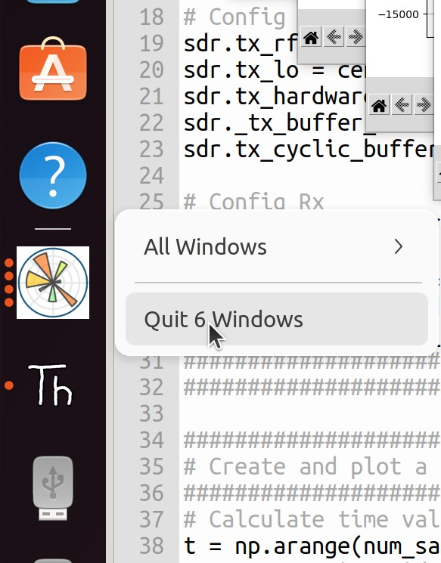

1. **Transmit and receive a complex sinusoid with Python (Jupiter or Talise). Wait your turn 😊.**
   1. From **ftc2023_sdr -> python -> sinewave_loopback** open**python_loopback_sine_jupiter.py (for Jupiter)** or**python_loopback_sine_talise_zu11eg.py** **(for Talise)** using **Thonny** as in **2.4.**
   2. Observe in the script where only the “Configure SDR” code section was changed in **python_loopback_sine_jupiter.py** and**python_loopback_sine_talise_zu11eg.py** compared to **python_loopback_sine_pluto.py** from **2.**

Jupiter:

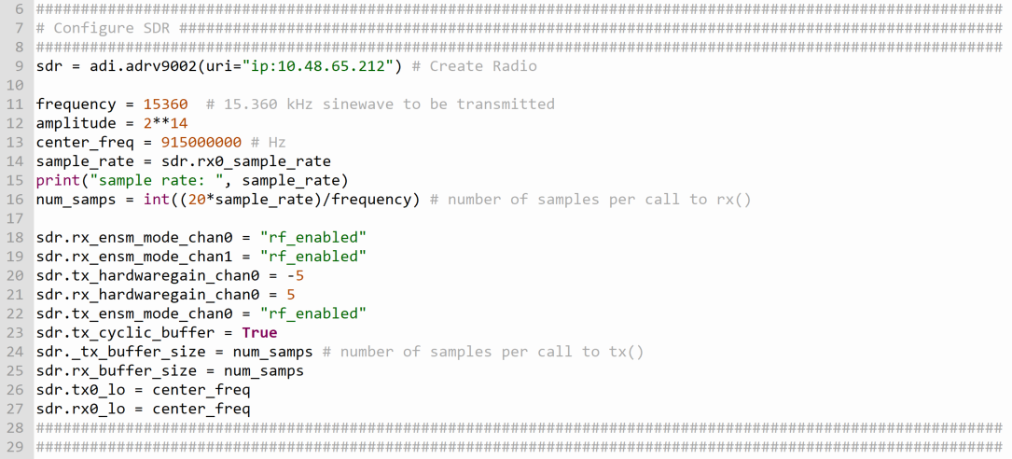

Talise:

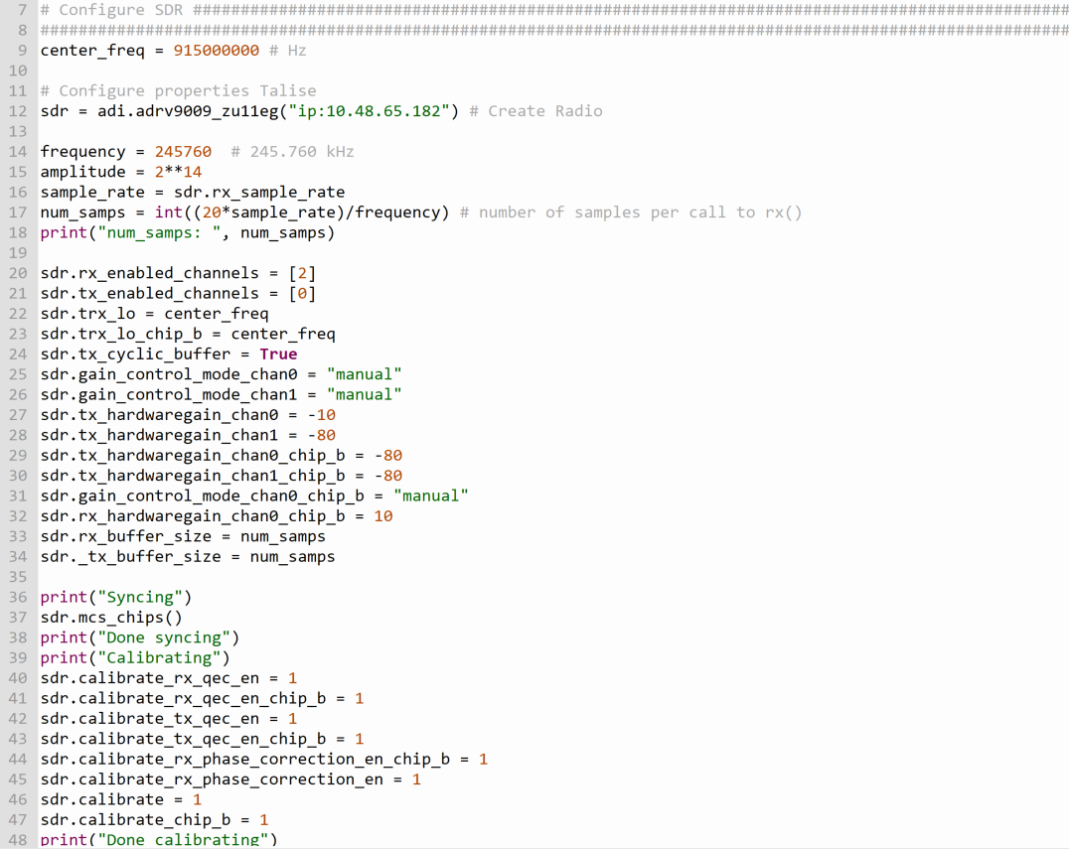

* 1. Insert the ip given for Jupiter on line 12 (in **python_loopback_sine_jupiter.py** or **python_loopback_sine_talise_zu11eg.py**) to remotely connect to Jupiter or Talise.

**Jupiter:**



**Talise:**



* 1. Run the script as indicated in **2.5.** In this example, a sinusoid at 15.360 KHz is transmiited and received. This frequency is chosen to have an integer number of periods of the sine at the sample rate of 15.36 Msps. More specifically, line 16 (depicted below) should return an integer number.



* 1. To zoom on the generated Figures, use the instructions given at **2.6.**
  2. To stop running the python script or if you want to run it again, use the instructions given at **2.7.**

1. **Doppler Radar with GNU Radio (Pluto)**
   1. Make the following setup using Pluto and connect it to your PC:

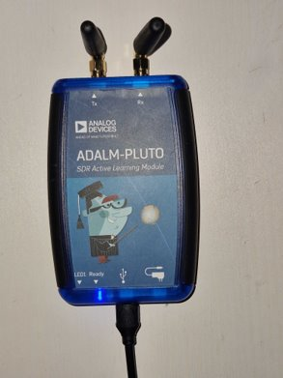

* 1. Open the terminal by pressing at the same time Ctrl + Alt + T.
  2. Type on the terminal **gnuradio-companion** and press Enter.
  3. Click on the **File -> Open**, and open from **Desktop -> ftc2023_sdr -> gnuradio**, **doppler_radar.grc** file.
  4. To run the flowgraph, press the grey arrow from the top function bar as indicated below.

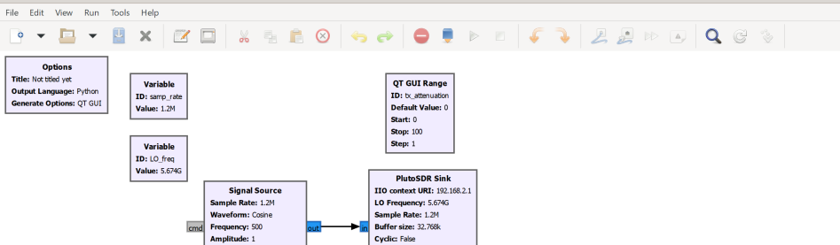

* 1. Move your hand toward and away from the antennas and observe how the sound changes as well as the frequency of the received harmonic from the real time plots.

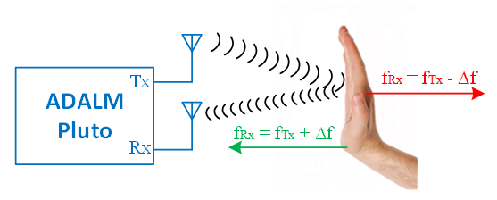

1. **Binary Shift Keying in Python (Pluto)**
   1. Make the following setup using Pluto and connect it to your PC:



* 1. Open **ftc2023_sdr** folder from your desktop.
  2. Go to **python -> bpsk_loopback** subfolder
  3. Right click on **bpsk_pluto_loopback_pluto.py -> Open With Other Application** and select **Thonny** from the Recommended Applications list.
  4. To run the script, press the green round button from the top left corner



* 1. To zoom on a plot use the instructions from **2.6.**
  2. To stop running the python script (if you want to run it again), close all the tabs by **right click on taskbar icon -> Quit x windows** as depicted below or close them manually one by one.



1. **Binary Shift Keying in Python (Jupiter and Talise)**
   1. From **ftc2023_sdr -> python -> bpsk_loopback** folder,open **bpsk_pluto_loopback_jupiter.py (for Jupiter)** or**bpsk_pluto_loopback_talise_zu11eg.py** **(for Talise)** using **Thonny** as in **2.4.**
   2. Observe in the script that only the Configure SDR portion was changed in **bpsk_pluto_loopback_jupiter.py** and **bpsk_pluto_loopback_talise_zu11eg.py** compared to **bpsk_pluto_loopback_pluto.py** from **5.**

Jupiter:

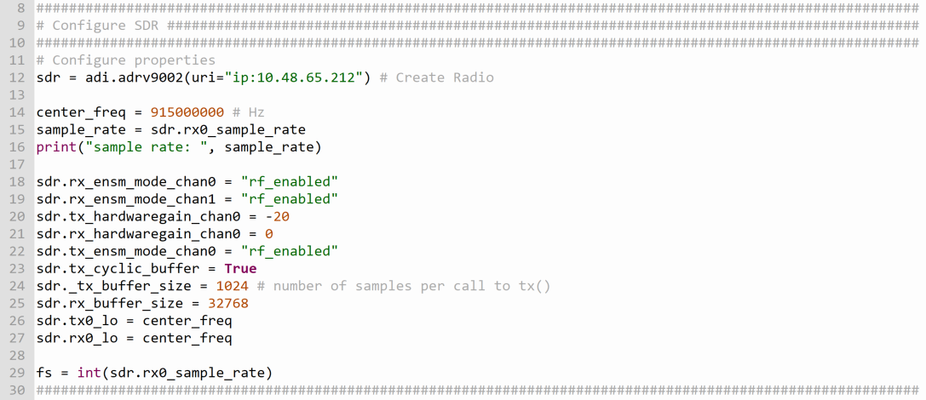

Talise:

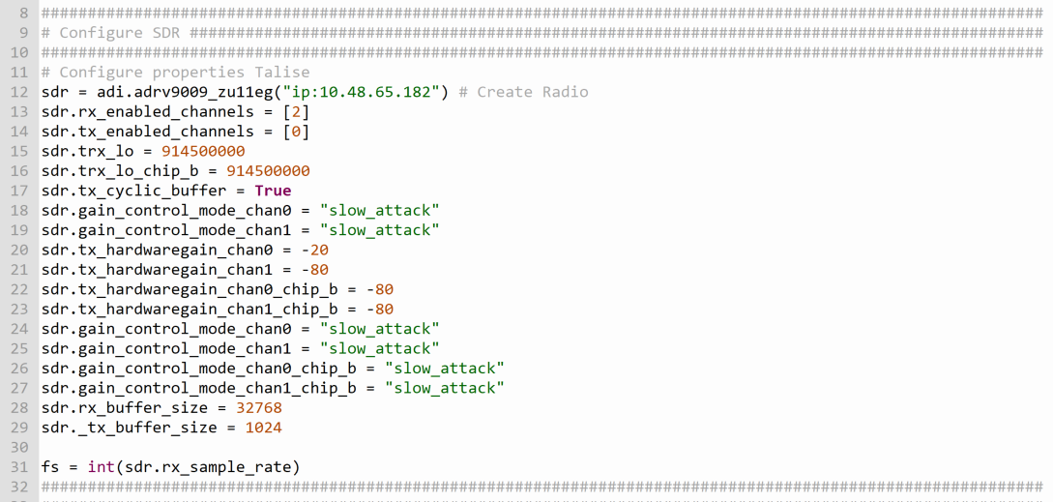

* 1. Insert the ip given for Jupiter on line 12 (in **bpsk_pluto_loopback_jupiter.py**) to remotely connect to Jupiter.

Jupiter:



Talise:



* 1. Run the script as indicated in **2.5.**
  2. To zoom on the generated Figures, use the instructions given at **2.6.**
  3. To stop running the python script or if you want to run it again, use the instructions given at **2.7.**

1. **Quadrature Shift Keying in GNU Radio (Pluto)**
2. **Receiving QPSK modulated Video with SDRs (Pluto)**
   1. Make the following setup using Pluto and connect it to your PC:



* 1. Open the terminal by pressing at the same time Ctrl + Alt + T.
  2. Type on the terminal **sdrangel** and press enter to open the application.
  3. The application should be preconfigured. Run the program by pressing the purple arrow as depicted below.

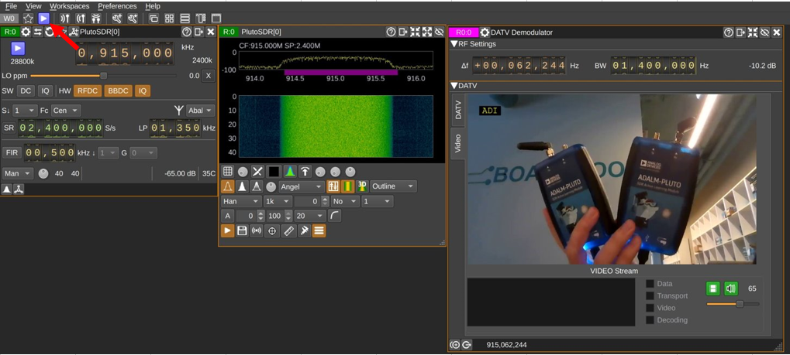

* 1. On DATV window, check Viterbi to synchronize the qpsk data.

(add picture)

1. **Spectrum Paint (Pluto)**
   1. Make the following setup using Pluto and connect it to your PC:

